MABC DIRECT DEPOSIT FORM

FULL NAME
MAILING ADDRESS
NAME OF INSTITUION (e.g TD, RBC etc)
TRANSIT NUMBER
BANK ID/INSTITUTION NUMBER
ACCOUNT NUMBER
NAME ON ACCOUNT (if different to above)

How to find this information on a personal cheque:
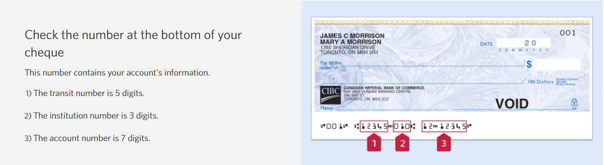

Please return this completed form to bookkeeping@bcmidwives.com

